Costing Worksheets Bundle (Excel Document)
This set of worksheets shows you all the shipping cost line items and lets a user calculate the shipping combined adder at a terminal_city + product combination. This also provides the details about tariffs and paths, plus a cross reference to find rates in future tariff documents.
Shipping Line Items: This is static data at a summary level. It can be used as a template to update data in a database.
- Shipping code – this is the code that tells you the city, terminal, and product
- Terminal code
- Product code – this is the product code that should match contracts and lifted product
- Index code – this is a unique concatenation of the quosrce, quotyp, quotno
- Price Day – this always prior day for shipping (with the combined adder = null)
- Line item type, line item adder, line item percent (as decimal)
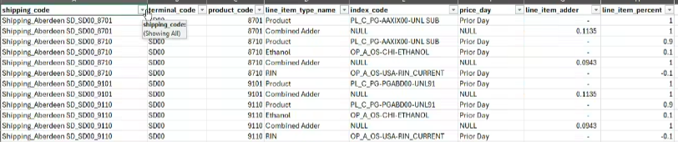
Costing Detail: This is a calculation tab. Expand to see the details. You can input a new value in one of the detail columns (no formula in cell) and it will recalculate the combined adder. You will then copy that new value into your shipping line item template sheet. Be careful to not type in a cell with a formula. **
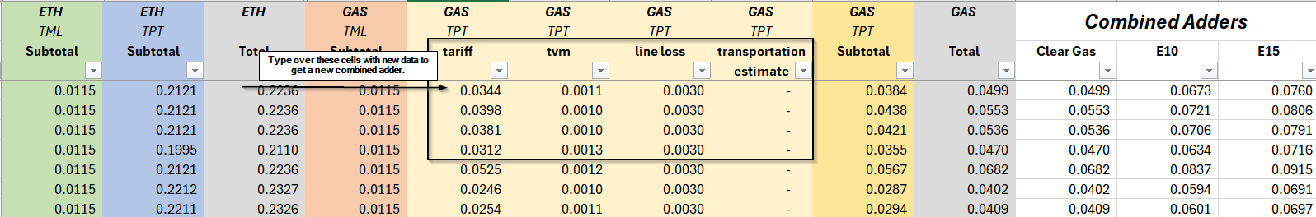
- Category – this groups costing types by ethanol or gas
- Costing Type – this groups costing items by transportation and terminaling
- Costing Item – these are the actual items that make up the cost of shipping product. Not every item applies to every product or every costing type.
  - Facilities Charge
  - Throughput
  - Additive – use when adding up specific terminaling costs, if not using an estimate
  - Terminaling Estimate – use this instead of Facilities Charge and Throughput
  - Tariff – actual tariff for the selected form of transportation. May not have tariff if refinery market.
  - Time Value of Money (TVM) – average of the average interest rates
  - Basis – this is generally a negative offset to the market of origin for this location
  - Margin – ethanol specific correction factor
  - Fuel Surcharge – ethanol requires an extra bit of transportation cost
  - Transloading Estimate – ethanol requires an extra bit of transportation cost
  - Truck Freight Estimate – ethanol requires an extra bit of transportation cost
  - Line Loss – generally line loss can be recovered through transmix sales, but it is included here as an expense because transmix sales are not controlled by the shipper.
Combined Adder Math: This is built up from the costing detail. Each costing item has a value and the subtotals of those values are calculated by summing the costing item values for that product category and costing type. Then, each product category totals are summed. The combined adder is calculated by using a weighted average of the product category totals.
**Subtotals, Total and Combined adders are all formulas in the spreadsheet set up to do this math.
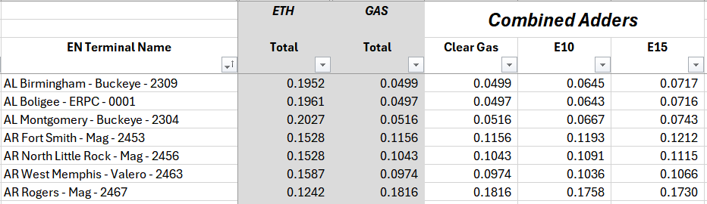
Clear gas = 0% ethanol, 100% gas; E10 = 10% ethanol, 90% gas; E15 = 15% ethanol, 85% gas
Paths and Tariffs: Information about how paths are set up. We don’t generally expect this to change, but it is available here to help a user to see which tariff to pick / how to update to a current tariff value or explain their numbers to someone. This is where you see the miles/time values for the TVM on that path, as well.
- Find location and product combination you are interested in looking up
- Move to column M+N to know what tariff got used in the existing shipping = green/green
  - You can filter on column N to see only published terminals
  - You can filter on column M to see only included paths
- The Tariff Library Name + tariff value are the hook you need here to go find the previous tariff documents and know how to find the newest tariff documents. The value in this one time export should match the value in the costing detail tab. NOTE: You may have to sum two tariffs to get the total in the costing tab. You will see them both listed.
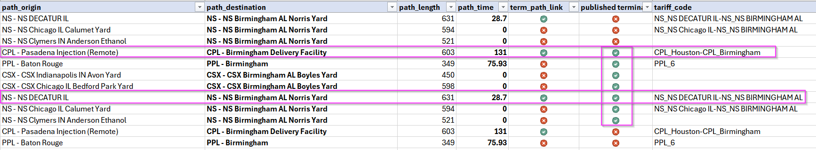
Tariff Cross Reference: This tab is to help a user track back to the tariff documents using the name in the published tariff. (usually a county and state). The location aliases and rates in this one time export should help a user be sure they have the correct template or tariff document when getting set up to look for new tariffs. Remember that tariffs are often in cents per barrel or dollars per barrel and all our values have been converted to dollars per gallon.

UPDATE PROCESS:
To update any data in the shipping line item tab, you will type over it and submit it to the person doing the database updates. We recommend saving a new file any time you are making updates so that you have both the old and the new version of the data.
Flag anything new in the template so they can identify the record(s) to change. You will need to tell them the shipping code and line item type name that has new data. Tell them what field has a new value and what the value in that field is. (Use the template to do this.)
- IF all you change is the combined adder, flag that row
- IF you also change an index, flag that row
Follow the same process if you change the terminal (shipping code/terminal code) or other details related to a set of shipping line items.
To insert new data you will need to have new rows in the worksheet tabs: Start a new set of shipping line items if you are shipping into a new market or have a new product that is not currently represented in this static data set. Follow the pattern of existing data to insert new data.
- Add your new terminal city in your costing detail, fill in those details that matter and add rows to the shipping line item tab.
- Add any new shipping codes, line items and new products in the shipping line items tab/template.
- Flag them as new in that tab to represent an insert into db versus and update to db.
Road Map
The initial data set provided is a snapshot in time current as of Jan 1, 2024.
Shipping costs generally are updated quarterly or as you get updated information.
- We would recommend adding start and end dates to the shipping data row, so that you know what costing data you used when. This allows you to keep a history of costs you believed / used at any given time. If you update a number, you would end the previous date and put in a new start date. (avoiding overlapping periods)
- We would recommend if using a spreadsheet and updating data right in the spreadsheet to get new costing numbers for a location that you do keep a clean copy of the template with the formulas and that you save a history file before making changes to the current file. This will help you maintain your history in a way that is defensible and usable by future folks looking at trends, buying performance or other key metrics.
- You will want to make changes to other fields besides the tariffs. An easy example is the Time Value of Money (aka the interest rate). You may want to use a real interest rate that you actually are paying vs the average of the average interest rate. Do this in a similar fashion as the tariff, making a historical copy, end dating the previous cost, and starting a new period. Normally we’d recommend you do that at the same time you are doing tariffs to keep the period start/end dates simple for any given location.
Loading this data into database data tables:
- We opted to make the format of the shipping costs “look” like a contract – product, percent, adders. This allows you to publish a combined adder for shipping in the same format as most contracts. This allows you to use structures, terms and calculations that are familiar to users and developers.

- We opted to have a costing table that kept “everything”, then use software code to publish a shipping cost for those locations that we had all the shipping components for – partial costings were not published to avoid artificially low costs in the final data tables.

- We had the idea of a shipping period that starts anytime a new cost appears and ends the previous cost period. You would need to estimate a future end date, but the start date is when you publish the new cost and begin to use it. We know tariffs update a couple times of year, so we picked end dates that go with either gas pipelines or ethanol tariffs to keep it simple. You always want to be using the current costs, and also know what the previous costs were.

- You may want to keep track of what you estimated vs what you know to be true. This could then be used to know how confident you are in any given component of the cost and the overall resulting cost for that location in that period.

- You will want to be able to explicitly include and/or exclude terminals. We did this through flags and link tables. You can see we publish costings for one terminal per market city.

